**Slime Lab (1 hr)**

**Summary:** This lab examines the impact of cross linking density on material properties in polymer networks (slime).

**ILOs:**

Relate crosslinking density to physical properties

Create a stress-strain curve from force and distance measurements

**Equipment list:**

* Glue (liquid)
* Baking soda
* Contact solution
* Ruler
* Force Gauges
* Any slime additives (food coloring, glitter, etc)
* Chopsticks (or stir sticks)
* Plastic cups
* Calipers (or rulers)
* force gauges

**Intro:**

Slime is a popular toy and activity, recently re-popularized by social media. However, how slime feels is a function of its polymer network properties. We will test how this is true by making two different slimes with different crosslinking densities.

**Procedure:**

How to make each slime texture:

|  |  |
| --- | --- |
| **Sticky** | **Thick** |
| ⅓ cup of glue | ⅓ cup of glue |
| 2-3 drops of food coloring | 2-3 drops of food coloring |
| 1 level spoonful of baking soda | 2 level spoonfuls of baking soda |
| 3 level spoonfuls of contact solution | 9 level spoonfuls of contact solution |

*IF YOU HAVE EXTRA TIME:*

How to make the “fluffy” slime texture:

|  |
| --- |
| **Fluffy** |
| 2/3 cup of glue |
| 2-3 drops of food coloring |
| ⅓ cup of shaving cream |
| 1 level spoonfuls of baking soda |
| 4 level spoonfuls of contact solution |

Steps:

1. Pour the glue into the cup
2. Add 2-3 drops of your choice of food coloring and stir until well mixed.
3. Add the baking soda and contact lens solution.
4. Stir with a spoon or with your hands. The slime will be quite sticky at first, but will get less so with more mixing.
5. You should now have 2 different consistencies of slime!
6. You have now made 2 or 3 (if you had extra time) different types of slime. Roll each one into a ball and try to bounce it on the floor. Note similarities and differences.
7. Now we will begin taking measurements to create a stress-strain curve. For the Thick slime:
   1. Roll one piece into a cylinder that is 10 cm in length and measure the radius of the end of the cylinder, then calculate the circle’s area.
   2. Roll the other piece into a cylinder that is 15 cm in length and measure the radius of the end of the cylinder, then calculate the circle’s area.
   3. For each cylinder:
      1. Attach the cylinder to the force gauge approximately 1 cm away from the end of the cylinder.
      2. Start pulling slowly on it. Record the length of the cylinder and the associated force at 3 different points in the table.
8. For the Thick slime, you have measured the original length, new lengths, areas, and forces. Use these observed values to calculate the engineering strain and stress for each of the data points using the following equations:

$$Engineering Strain ε = \frac{L-L_{0}}{L_{0}}$$

$$Engineering Stress σ=\frac{F}{A_{0}}$$

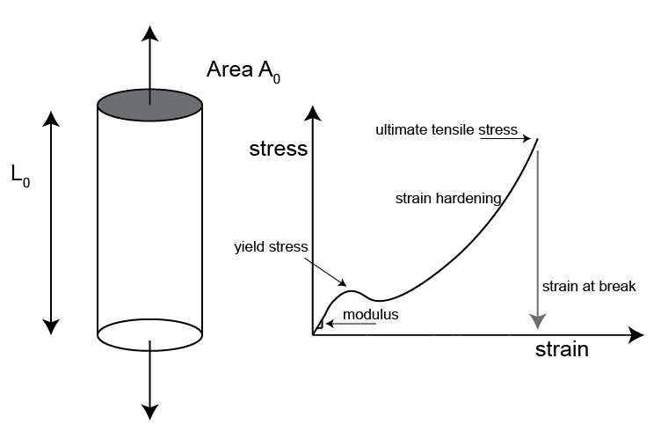

**Discussion questions/debrief:**

1. How are the slimes different in terms of texture, appearance, and how it bounces? How are they similar?
2. Describe your stress -strain graph. How is it different from what you expected? How is it similar?

**Lab handout needed?**

Yes